Data Summary and Description
For this project, we collected and processed wildfire and climate data to model and predict fire occurrence across the state of California between 2010 and 2025. The wildfire data was sourced from NASA’s Fire Information for Resource Management System (FIRMS), which includes observations from two satellite instruments: the Moderate Resolution Imaging Spectroradiometer (MODIS) aboard Aqua and Terra, and the Visible Infrared Imaging Radiometer Suite (VIIRS) aboard S-NPP and NOAA-20.
The raw FIRMS dataset contained the following attributes: latitude, longitude, brightness, acquisition date (acq_date), satellite, instrument, confidence, and bright_t31. From this, we retained key variables relevant to fire detection: latitude, longitude, acq_date, satellite, instrument, confidence, and extracted the year and month for temporal grouping.
In addition to fire data, we incorporated relevant climate features from NOAA, including total monthly precipitation, relative humidity at 2 meters, wind speed range at 10 meters, normalized difference vegetation index (NDVI), mean and maximum temperatures, surface (skin) temperature, and terrain attributes such as elevation, slope, and aspect.
To prepare the dataset for analysis, we performed the following preprocessing steps:
- Filtered fire records to include only observations within California from 2010 to 2025.
- Rounded latitude and longitude values to two decimal places to allow spatial grouping.
- Grouped the data by rounded latitude, longitude, month, and year.
- Calculated the monthly fire count for each location and time period.
- Averaged climate features within each grouped region and time frame.
- Merged the fire and climate data using latitude, longitude, month, and year as common keys

To define the target variable for our classification model, we applied the following logic: if a location had more than one fire in a given month and the average fire detection confidence was greater than 60, then the binary target variable Fire_occurrence was assigned a value of 1 (indicating fire presence); otherwise, it was set to 0.
This comprehensive dataset served as the foundation for building and evaluating machine learning models to predict wildfire occurrence based on environmental, meteorological, and topographical indicators.

Feature Name | Description | Type
latitude | Rounded latitude of the location (2 decimal places) | Numerical
longitude | Rounded longitude of the location (2 decimal places) | Numerical
year | Year of observation | Categorical
month | Month of observation | Categorical
year_month | Combined year and month (format: YYYYMM) | Categorical
confidence | Average fire detection confidence (%) | Numerical
fire_count | Number of fire incidents in the location during the month | Numerical
PRECTOTCORR_SUM | Average total monthly precipitation (mm) | Numerical
RH2M | Average relative humidity at 2 meters (%) | Numerical
WD10M | Average wind direction at 10 meters (degrees from North) | Numerical
WS10M_RANGE | Average wind speed range at 10 meters (m/s) | Numerical
NDVI | Normalized Difference Vegetation Index (0–1 scale) | Numerical
T2M | Mean monthly temperature at 2 meters (°C) | Numerical
T2M_MAX | Maximum monthly temperature at 2 meters (°C) | Numerical
TS | Average skin (surface) temperature (°C) | Numerical
elevation | Average elevation of the region (meters) | Numerical
slope | Average slope of the region (degrees) | Numerical
aspect | Average terrain aspect (degrees from North) | Numerical
Fire_occurrence | Target variable: 1 if fire_count > 1 and confidence > 60, else 0

Analysis
To gain a deeper understanding of the factors contributing to wildfire occurrence, we conducted comprehensive exploratory data analysis (EDA) on the prepared dataset. Our goal was to uncover patterns, relationships, and seasonal trends among climate features and fire events across California from 2010 to 2025.

1. Correlation Analysis
We started by examining the pairwise correlations among numerical features to identify potential predictors of wildfire occurrence and multicollinearity issues. The correlation heatmap revealed strong positive correlations among temperature variables (T2M, TS, T2M_MAX) with a correlation of ≈ 0.96–1.00, suggesting they are closely related. These temperature variables also showed a moderate positive correlation with wildfire severity (≈ 0.20), indicating higher temperatures are linked to more severe wildfires. In contrast, relative humidity (RH2M) exhibited strong negative correlations with temperature variables (≈ -0.86 to -0.88) and severity (-0.21), confirming the inverse relationship between humidity and fire intensity. Wind speed range (WS10M_RANGE) had a moderate positive correlation with RH2M (0.60) but weakly negatively correlated with severity (-0.07). NDVI, which measures vegetation health, showed minimal correlations with other variables and a negligible correlation with severity (-0.05), indicating it may not be a strong predictor. Overall, temperature and humidity emerge as key factors in wildfire severity.

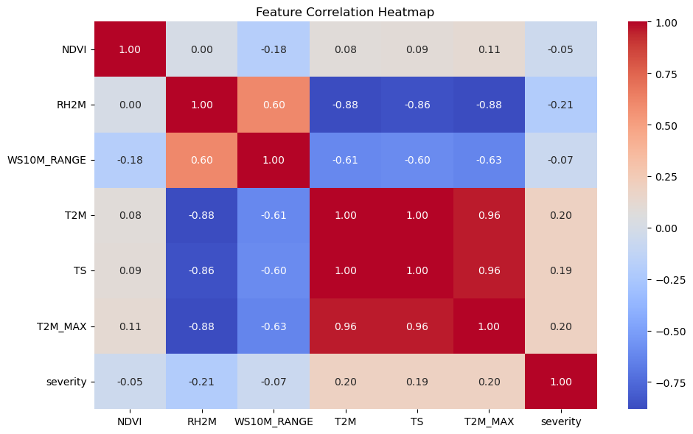

2. Spatial Distribution of Wildfires
The hexbin density map visualizes wildfire occurrences across California, with darker red regions indicating higher densities. Major hotspots are concentrated in Northern, Central-Eastern, and Southern California, especially near Crescent City, Fresno, and Los Angeles. A significant number of wildfires are observed in national forest regions, highlighting their vulnerability. The year 2020 saw the highest wildfire activity, with 270,710 incidents recorded. The spatial distribution suggests a correlation between fire frequency and forested or mountainous terrains. Urban areas like Sacramento and San Diego show lower fire density compared to forested interiors. This analysis provides critical insight into regional fire risk patterns for better resource allocation and mitigation planning.
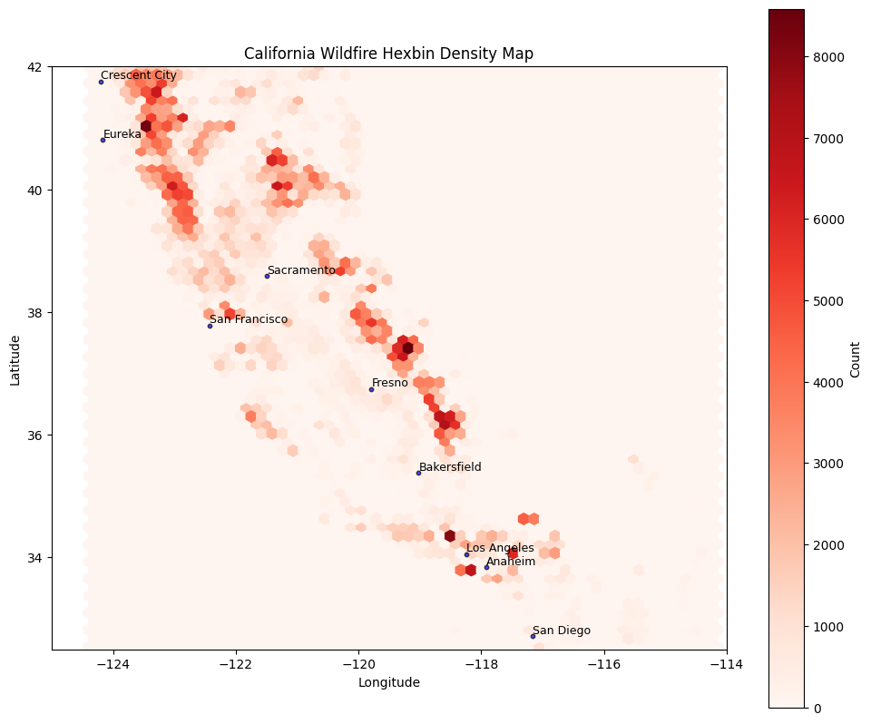

3. Feature Relationship with Fire Confidence
We examined the relationship between fire detection confidence and key climate indicators:
- NDVI vs. Confidence: Lower vegetation density (lower NDVI) was generally associated with higher fire confidence, likely indicating drier, more fire-prone conditions.
- Temperature vs. Confidence: Higher temperatures correlated with higher fire confidence, supporting the role of heat in fire ignition and spread.
- Humidity vs. Confidence: Confidence decreased as relative humidity increased, reflecting the dampening effect of moisture on fire activity.
- Wind Speed Range vs. Confidence: Moderate to low wind speed ranges were associated with higher confidence, emphasizing wind’s role in fire acceleration.
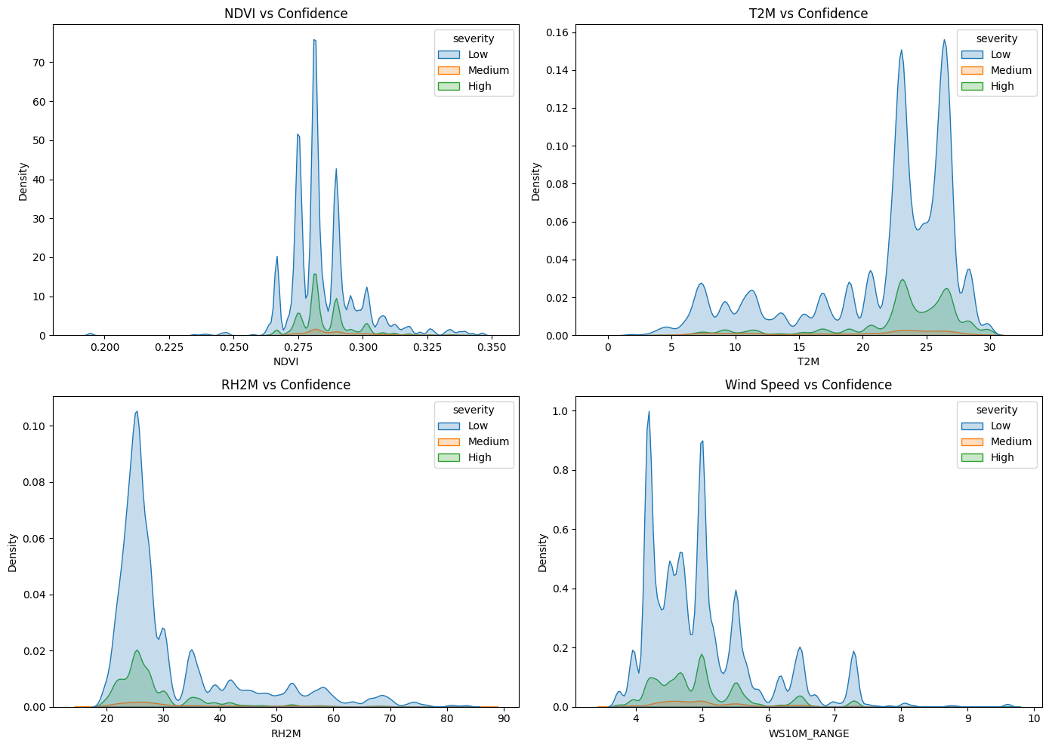

4. Seasonal Variation
We explored monthly variation in several climate features to assess seasonal wildfire risk. Key observations included:
- Temperature peaked during summer months, when fire activity was also highest.
- NDVI was lowest during August, September, and October, coinciding with the highest fire counts. This suggests poor vegetation health during these months may contribute to an increased risk of wildfires.
- Humidity and Precipitation were generally lowest in the same period, contributing to drier conditions.
- Wind Speed Range showed variability throughout the year but tended to rise during peak fire months.
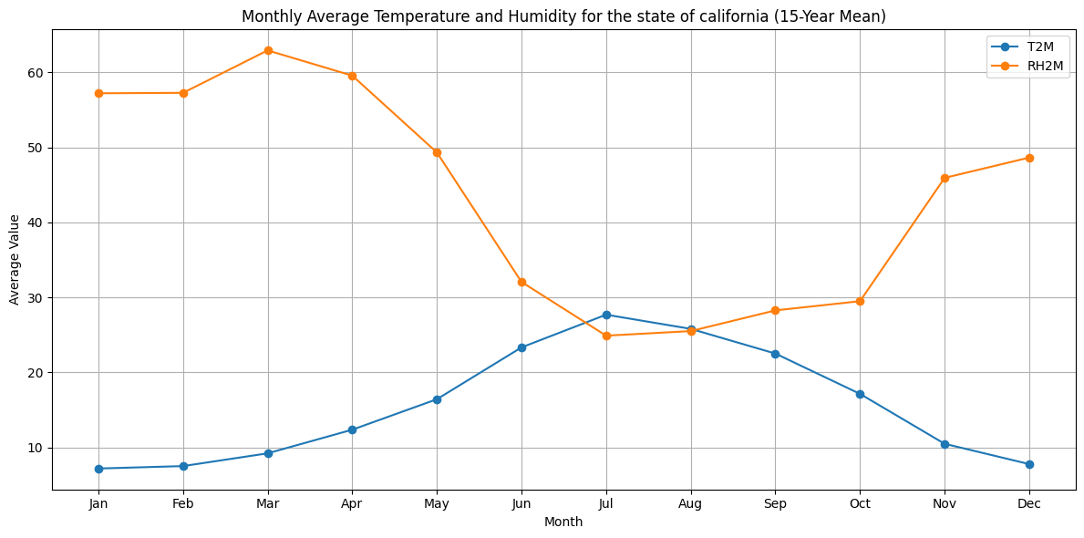
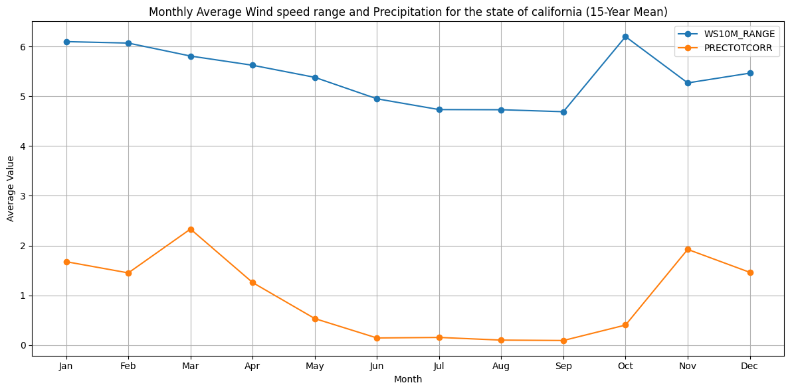
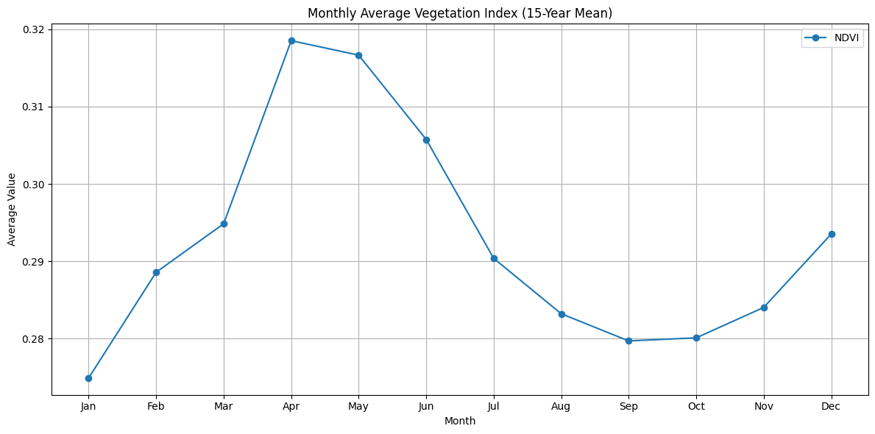

5. Monthly Wildfire Frequency
A month-wise aggregation of fire occurrences revealed a clear seasonal pattern. The majority of wildfires occurred between July and October, aligning with California's dry season. These months exhibited both high fire counts and favorable conditions for fire ignition and spread.
